
[Document title]

`1

1. Project Overview and Objective:
Project Overview
This project focuses on analysing retail sales transaction data using Microsoft Excel and Power BI. The provided workbook contains a main retail sales table along with product and customer reference tables. The project will use these data to examine transaction amounts, product categories, customer activity, payment methods, discounts and loyalty points.
Project Objective
The main objective is to understand retail sales performance and customer purchasing patterns, identify high-performing products and categories, review payment and discount trends, and present the findings through clear, interactive Power BI reports.
2. Data Sources
Source Description and Timeline: The source is the clean data Excel workbook supplied for this project. The workbook contains three worksheets: retail sale, prodcut-id and cust-id. The transaction dates in the main sales sheet range from 05 January 2024 to 25 November 2024. The original external dataset publisher/source is not specified in the workbook.
Domain: Retail / Commerce / Sales Analytics. The data represents retail transactions, product details and customer reference information.
3. Problem Statement
To analyse overall retail sales performance using transaction amount and final amount, and identify sales patterns over the available transaction period.
To identify the products and product categories that contribute most to sales, based on quantity sold and transaction values.
To understand customer purchasing activity and compare sales across customers using the customer reference data.
To examine payment-method usage, discounts and loyalty points earned in order to identify useful patterns that can support retail business decisions.
4. Attribute (Column / Features) Details
Attribute Name | Data Type | Description
txn_id | Text | Unique identifier for each sales transaction.
Prodcut-id | Text / Key | Product identifier used to link a transaction to the product reference table.
customer-id | Text / Key | Customer identifier used to link a transaction to the customer reference table.
transaction_date | Date | Date on which the sales transaction took place.
customer_name | Text | Name of the customer recorded for the transaction.
product_name | Text | Name or description of the product sold.
category | Categorical / Text | Product category recorded for the transaction.
quantity | Integer | Number of units purchased in the transaction.
unit_price | Integer / Numeric | Price per unit of the product.
total_amount | Integer / Numeric | Transaction amount before the discount, as recorded in the dataset.
payment_method | Categorical / Text | Payment method used for the transaction.
discount_percent | Decimal / Numeric | Discount percentage applied to the transaction.
discount_amount | Decimal / Numeric | Discount value recorded for the transaction.
final_amount | Decimal / Numeric | Final transaction amount after discount, as recorded in the dataset.
cashier_name | Text | Name of the cashier associated with the transaction.
receipt_number | Text / Identifier | Receipt reference number for the transaction.
loyalty_points_earned | Integer | Number of loyalty points earned from the transaction.
prodcut-id (reference sheet) | Text / Key | Product identifier in the product lookup worksheet.
product-name (reference sheet) | Text | Product name in the product lookup worksheet.
customer-id (reference sheet) | Text / Key | Customer identifier in the customer lookup worksheet.
customer name (reference sheet) | Text | Customer name in the customer lookup worksheet.
5. Tools & Technologies
Excel: Used for reviewing the workbook, data validation, data cleaning, sorting, filtering, data transformation and Pivot Table summaries.
Power BI: Used for importing the Excel data, building relationships between sales, product and customer tables, creating DAX measures, and developing interactive visual reports.
6. Data Pre-Processing (Excel / Power Qoury)
- Data Cleaning & Transformation: Removed duplicates, handled missing values, standardized formats, and created calculated fields.
- Filtering & Sorting: Organized data to focus on relevant records.
- Using formal : 1 usinf =isblank(0)
2 using xlooup to combine table
7. Data Modelling and DAX (Power BI)
- Data Model: Established relationships between tables, defined cardinality, and created lookup tables where necessary.

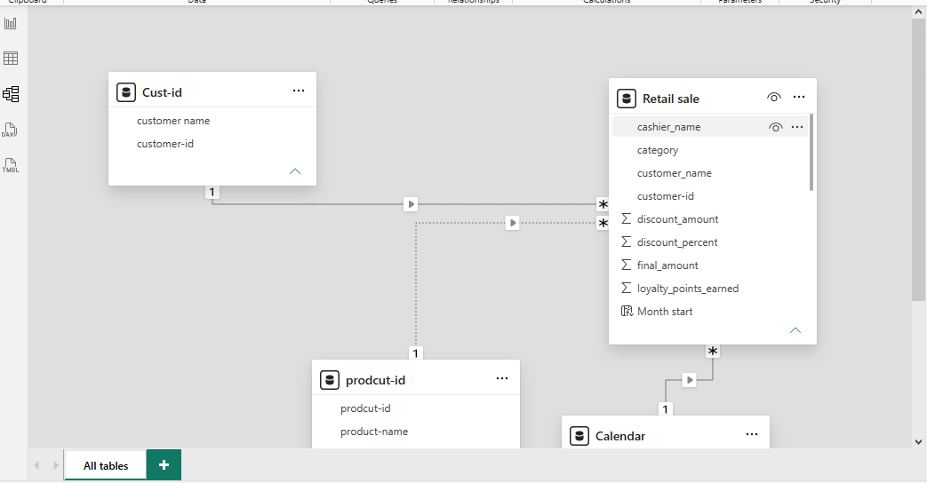

- Calculated Columns & DAX Measures: Implemented DAX formulas for key metrics, such as total sales, growth percentages, and cumulative totals. (List Out)
- Calendar = ADDCOLUMNS(
- CALENDAR(min('Retail sale'[transaction_date]),
- max('Retail sale'[transaction_date])
- ),
- "year",YEAR([Date]),
- "month",FORMAT([Date],"mm"),
- "month number",MONTH([Date]),
- "month year",FORMAT([Date],"mmm yyyy"),
- "month sort",YEAR([Date])*100+MONTH([Date])
- )
&
DAX MESURSE
TOTAL SALE :
total discount = sum('Retail sale'[discount_amount])
TOTAL ORDER VALUE :
total order value = DIVIDE([total sale],[total transactions],0)
TPOTAL QUANTITY:
total quantity = sum('Retail sale'[quantity])

8. Analysis and Visualizations (Power BI)
Dashboard Features:
- Multiple Visualizations based on problem statement: Bar charts, line charts, pie charts, cards, and tables to communicate insights. (List Out)
- Make your Report interactive Layout using Drill-down, Filters and slicers
- Bookmarks, Clear Titles for each visuals & Labels is must.
Create a consolidated Report /Dashboard
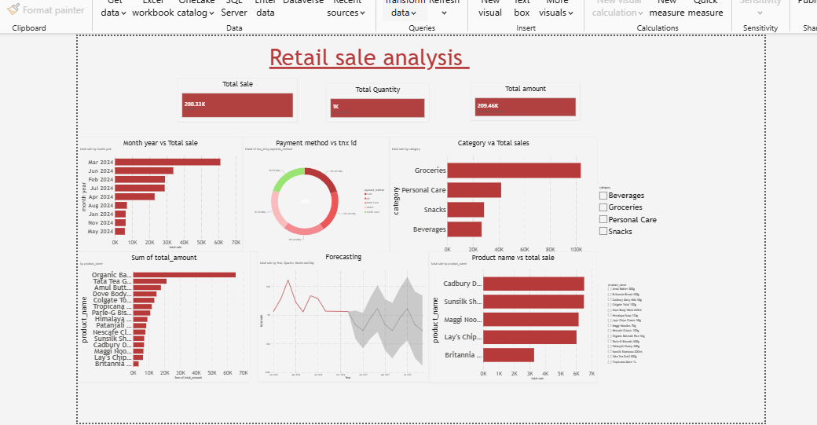
9. Insights & Conclusions
KEY FINDING :
- 1. Total Sales: The business generated approximately 200.33K in total sales.
- 2. Total Quantity: Around 1K units of products were sold.
- 3. Total Amount: The overall transaction amount is approximately 209.46K.
- 4. Top-Selling Category: Groceries generated the highest sales, contributing approximately 105K, followed by Personal Care, Snacks, and Beverages.
- 5. Best Performing Month: March 2024 recorded the highest sales at approximately 60K.
- 6. Lowest Performing Month: August 2024 recorded comparatively low sales.
- 7. Top Product by Amount: Organic products generated the highest amount, followed by Tata Tea and Amul Butter.
- 8. Product Sales Performance: Cadbury Dairy Milk, Sunsilk Shampoo, and Maggi Noodles were among the leading products based on total sales.
9. Payment Analysis: The donut chart shows the distribution of transactions across different payment methods.
10. Sales Forecast: The forecasting visual indicates expected future sales with an uncertainty range, suggesting possible fluctuations in upcoming sales.
. Descriptive Analysis – What happened?
- Total sales reached approximately 200.33K.
- Around 1K product units were sold.
- Groceries recorded the highest category sales (approximately 105K).
- March 2024 was the best-performing month, with sales of approximately 60K.
- Organic products generated the highest product-level amount.
2. Diagnostic Analysis – Why did it happen?
- Grocery sales were higher because this category contributed more sales than other categories.
- March recorded the highest sales, indicating stronger customer purchases during that month.
- Personal Care ranked second, while Snacks and Beverages recorded comparatively lower sales.
- Sales varied across months, suggesting changes in customer demand and purchasing patterns.
- A few products contributed a larger share of total sales than others.
3. Predictive Analysis – What is likely to happen?
- The forecasting chart indicates that future sales may fluctuate.
- Sales are expected to continue varying within the forecast confidence interval.
- High-performing categories such as Groceries may continue contributing significantly to revenue.
- The business can use historical sales trends to estimate future demand and prepare inventory.
4. Prescriptive Analysis – What should we do?
- Increase inventory for high-demand grocery products.
- Introduce discounts and promotional offers for low-performing categories.
- Focus on improving sales of Beverages and Snacks.
- Maintain sufficient stock of popular products such as Organic products, Tata Tea and Amul Butter.
- Use monthly sales forecasts to plan inventory and marketing campaigns.
- Monitor payment methods and customer purchasing patterns to improve the shopping experience.
Final Conclusion
The analysis shows that Groceries are the strongest-performing category, with March 2024 recording the highest monthly sales. By improving low-performing categories, maintaining popular product inventory, and using forecasting for future planning, the business can increase sales and improve overall performance.

